9.61: a) For a clockwise rotation, 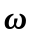 will be out of the page. b ) The upward direction crossed into the radial direction is, by the right-hand rule, counterclockwise. 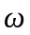 and are perpendicular, so the magnitude of 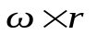is c) Geometrically, is perpendicular to 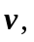 and so 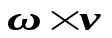 has magnitude 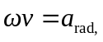 and from the right-hand rule, the upward direction crossed into the counterclockwise direction is inward, the direction of 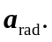 Algebraically,
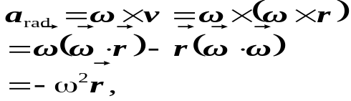
where the fact that and are perpendicular has been used to eliminate their dot product.

